Tech Nation Visa — Global Talent (Exceptional Promise)
Criteria: Mandatory Criteria — Innovation and Potential Leadership
Applicant: Odeyemi Olusegun Israel

MC-1: Public AMTTP Deployment and External Validation
1. Claim

I independently designed and publicly deployed AMTTP, a real-time AML enforcement platform that makes risk decisions before blockchain settlement. This proves more than technical ability: it shows initiative, public release, user exposure, and external validation for an original digital-technology product.
Claim | Evidence | Independent verification
Public product exists | amttp.com live deployment | Cloudflare analytics + public URL
Public interest | 1,220 unique visitors; 38,320 requests | Cloudflare independent infrastructure analytics
Working system | 4-minute demo and product screens | YouTube demo + War Room screenshots
External validation | Signed/sealed pilot agreement | Glitterati Estates Schedule A + signature/seal

Why this matters: AMTTP shifts AML from post-event reporting to pre-settlement enforcement, directly addressing a major digital-asset compliance problem: once assets move on-chain, reversal is difficult or impossible.
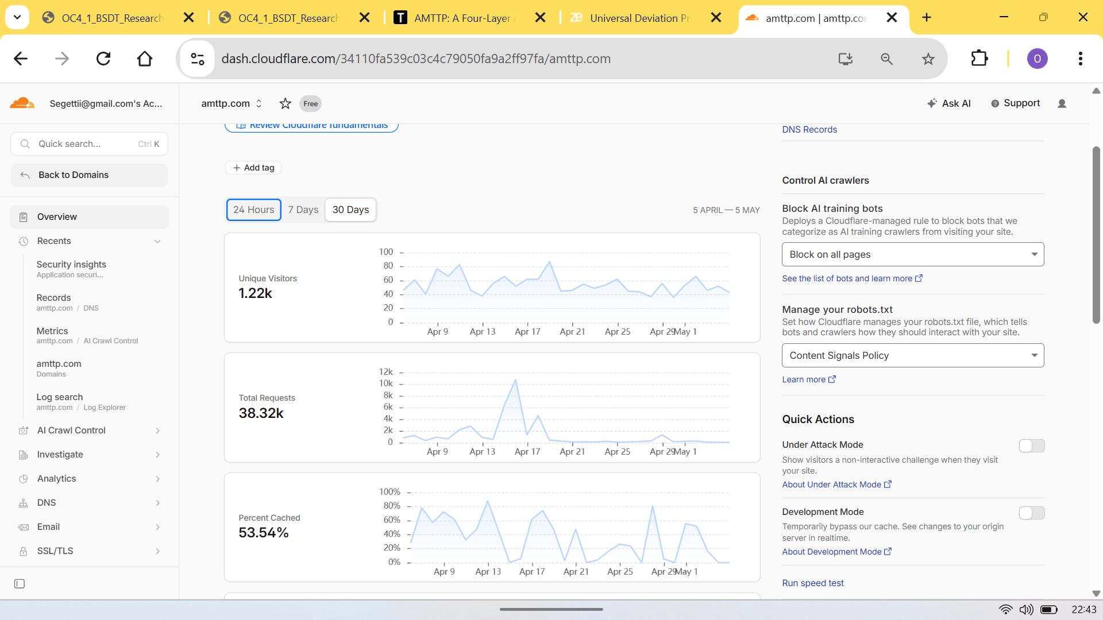
Figure 1: Independent Cloudflare analytics for amttp.com — public traffic evidence outside the applicant's control.
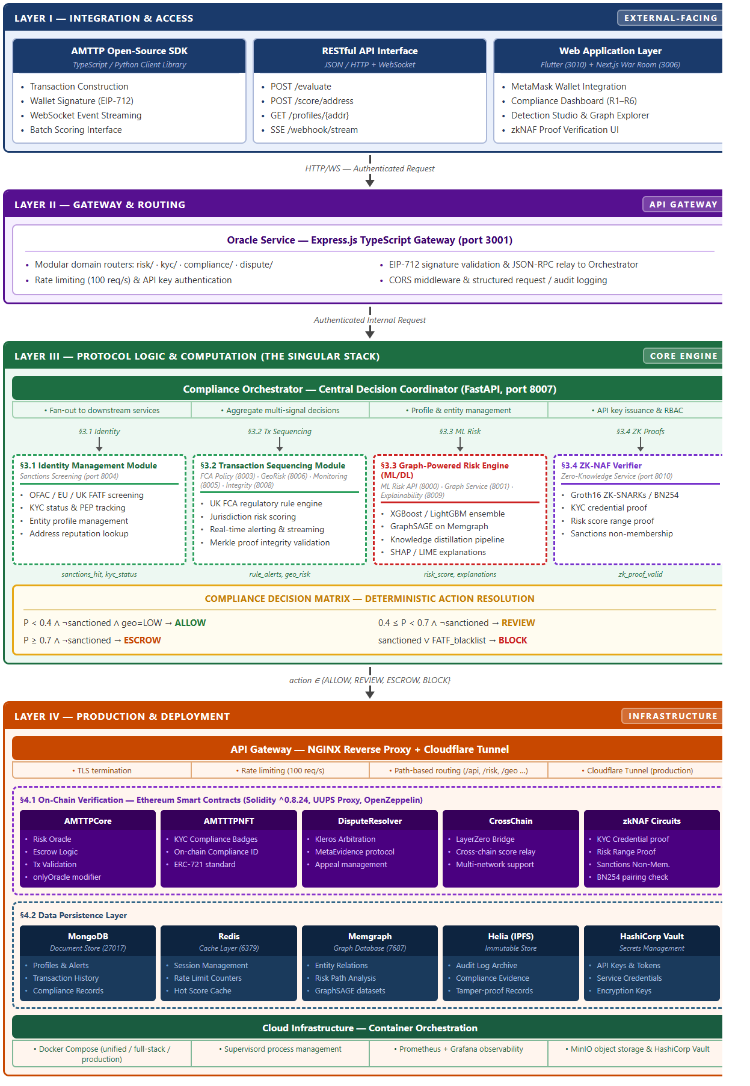
Figure 2: Four-layer architecture: Flutter/Next.js frontends, Express gateway, nine FastAPI services, Solidity contracts.
Anti-loophole note: This exhibit does not rely only on screenshots. It ties the product to third-party infrastructure analytics, a public URL, a video demonstration, and a signed/sealed external pilot document.

